AT2

Movie Database Application

Software Development Master Document

Team Name:

Team Bare Maximum

Members:

Reece Pieri, Rico Imbang, Say Hon Lee

Diploma of Software Development - RAD:

Diploma of Software Development

Rapid Application Development

Contents

1 Introduction 4

1.1 Purpose of the Software Development Master Document 4

2 Team 4

2.1 Team Information 4

3 Sprint One 5

3.1 Team 5

3.2 Source Control Snapshot 5

3.3 Project Management Plan 6

3.4 Software Development Testing Plan 7

1 Introduction 7

1.1 Purpose of the Software Development Testing Plan 7

1.2 Scope 7

1.3 Quality Objective 8

1.4 Roles and Responsibilities 8

2 Test Methodology 9

2.1 Overview 9

2.2 Test Levels 9

2.3 Bug Triage 10

2.4 Test Completeness 10

3 Test Deliverables 11

4 Resources & Environment 11

4.1 Testing Tools 11

4.2 Test Environment 11

3.5 Analysis Report 12

CITE Business Rules for Software Development 12

CITE Managed Services Quality Assurance 13

Acme Entertainment Pty Ltd Development Requirements 13

3.6 Multi-platform Report 14

1 Introduction 14

1.1 Purpose of the Multi-platform Report 14

2 Adaptive Design 15

2.1 Definition of Adaptive Design 15

2.2 Advantages and disadvantages of Adaptive Design 15

3 Responsive Design 16

3.1 Definition of Responsive Design 16

3.2 Advantages and disadvantages of Responsive Design 16

4 Conclusion 17

3.7 Test Document 18

Test Data 18

# 1 Introduction

## 1.1 Purpose of the Software Development Master Document

The purpose of the Software Development Master Document is to serve as a central source of information pertaining to all aspects of the development of the Movie Database Application.

# 2 Team

## 2.1 Team Information

Team Name: Team Bare Maximum

Members: Reece Pieri (M087496)

Rico Imbang (30019932)

Say Hon Lee (30003628)

# 3 Sprint One

## 3.1 Team

Scrum Master: Reece Pieri

Members: Rico Imbang, Say Hon Lee

## 3.2 Source Control Snapshot

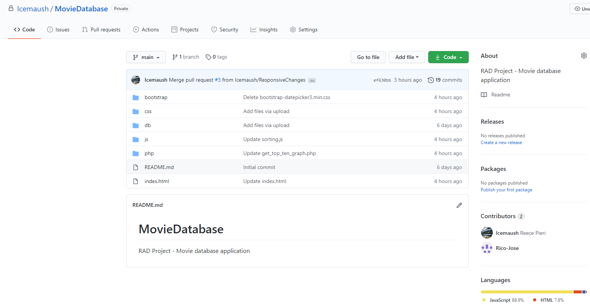

## 3.3 Project Management Plan

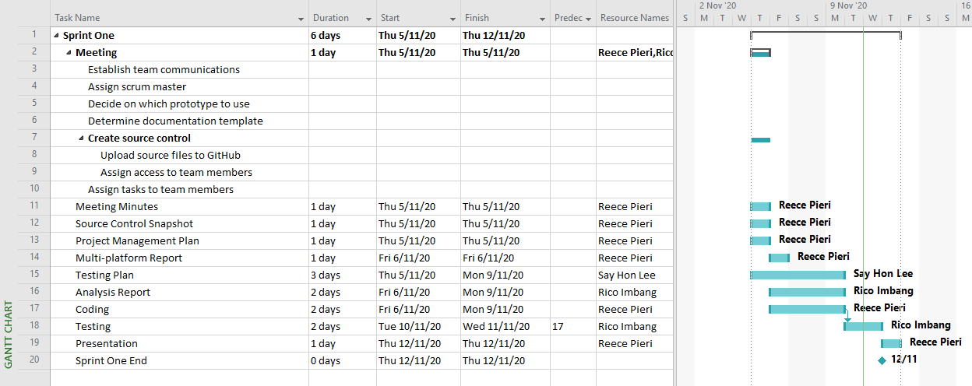

## 3.4 Software Development Testing Plan

1 Introduction

1.1 Purpose of the Software Development Testing Plan

The purpose of the Software Development Testing Plan is to outline the scope and strategies that will be applied to the testing of the Movie Database application.

1.2 Scope

The functional requirements of the Movie Database application include:

* Displaying all available movies
* Connection to database
* Searching of specific movies
* Searching movies by name, genre, released year or ratings
* Displaying the top 10 movies searched by user in graph
* Compatible with multiple device such as computers, tablet and mobile devices.

The non-functional requirements of the Movie Database application include:

* Responsive time of the website
* Maintainability of the website
* Security of the database
* Software flexibility (moving from one operating system to other operating system shouldn’t crash the website)

1.3 Quality Objective

* Ensure the application functional and non-functional requirements meets the client expectations.
* Ensure the AUT meets the quality specifications requested by the client.
* Bugs and issues are identified and fixed before releasing the product into the market.

1.4 Roles and Responsibilities

All team members will be contributing to all aspects of the development of the application. Tasks and responsibilities will rotate weekly with each sprint.

2 Test Methodology

2.1 Overview

Due to the client’s requirement not being clearly outlined at the beginning of the project, the testing methodology best suited for this project is the Agile methodology due to its flexibility and the need to present a working prototype to the client frequently. This allows the improvement of the product quality in a progressive manner.

2.2 Test Levels

Four stages of testing will be applied to the Movie Database application. These include:

* Unit testing – it is a smallest testable portion of the systems ensuring it could be compiled, loaded and executed.
* Integration testing – as the website is connected to a database we will also need to ensure that data would be displayed onto the webpage while customers visit the page.
* System testing – it refers to checking the overall interaction of the components built in the webage to check on the loading, performance, reliability and security of the webpage.
* Acceptance testing – is to test the conduct to find if the requirements of a specification or contract are met as per its delivery. I will be tested by the clients to ensure the level of satisfactory have been met.

2.3 Bug Triage

The purpose of bug triage is to define the resolution type of each bug detected during testing and prioritize fixes based on bug severity and determine a schedule to apply bug fixes.

2.4 Test Completeness

Once testing is complete and bug fixes have been applied, the acceptance test will be completed to ensure no new bugs are introduced and all functionality meets the client’s requirements.

3 Test Deliverables

At the end of each testing phase a Testing Document will be produced. This document will contain a test table which will describe the tests that have been performed as well as screenshots of the test results.

4 Resources & Environment

4.1 Testing Tools

The IDE debugger will be used to detect and assist in resolving existing bugs and errors in the application and also to ensure that the code can be compiled, making sure that all the functions and requirements are working as per the client requirements.

4.2 Test Environment

The following software is required in addition to client-specific software.

* Devices: PC, tablet, smart phone
* Browsers: Google Chrome, Mozilla Firefox, Safari, Microsoft Edge
* Webserver with PHP and MySQL
* Internet connection

## 3.5 Analysis Report

CITE Business Rules for Software Development

CITE Managed Services (CITE MS) develops software for a range of clients. CITE MS has employees but they utilise external contractors when necessary and all of them must adhere to the company policy.

CITE MS uses Software Development Life Cycle (SDLC) as a process to design, develop, test, and maintain high quality applications. To ensure that any software that will be developed will be adequately documented and tested before it is used for sensitive client information, the SDLC should at least address the following areas:

* Preliminary analysis or feasibility study
* Risk identification and mitigation
* Systems analysis
* Design specification
* Development
* Quality assurance
* Implementation
* Post-implementation maintenance and review

Coding standards must be followed when developing applications for or at CITE MS. To ensure security is rigorously maintained for the production system while the development and test environments can maximise productivity with fewer security restrictions, there must be a separation between the production system, development and test environments. Also, development and test staff must not be permitted to have access to production systems.

CITE Managed Services Quality Assurance

CITE MS has established processes that evaluate project performance, assure that quality standards are being followed, and that the deliverables comply with customer requirements. A Quality Management System (QMS) has been implemented which comprises a complex set of engineering and managerial activities that ensure quality of delivered software throughout the entire workflow. QMS Tasks and Objectives are the following:

* Elaboration and implementation of procedures and regulations for software development process based on industry standards and best practices;
* Product lifecycle monitoring to ensure compliance with established processes and guidelines
* Product quality verification and validation to ensure that it complies with clients’ business needs and expectations;
* Establishment of an effective collaboration between all project team members.

Acme Entertainment Pty Ltd Development Requirements

Acme Entertainment have commissioned the movie database project and CITE MS have presented a prototype. However, its user interface is designed primarily for desktop computers and Acme requires it to function correctly on major platforms (desktop computer, tablet, and cell phone). To accomplish this task, the interface must utilise either adaptive or responsive design. The project can be hosted on the cloud or a suitable local server.

## Multi-platform Report

1 Introduction

1.1 Purpose of the Multi-platform Report

The purpose of the Multi-platform Report is to outline the differences between the two design options, Adaptive and Responsive Design, and to come to a conclusion on which design is more suitable for the Movie Database Application.

This document aims to clearly describe each design option and provide advantages and disadvantages of each, as well as describe the reason for our selected design approach.

2 Adaptive Design

2.1 Definition of Adaptive Design

Adaptive Design is the design of a website in which there are several fixed layout sizes. When the website is loaded it detects the amount of space that is available and select an appropriate layout size which is then displayed on screen. Adaptive Design is more suitable for designing websites that target a specific device.

2.2 Advantages and disadvantages of Adaptive Design

Benefits of Adaptive Design include allowing designers to build amazing websites tailored to a specific device and being able to optimize advertisements based on user data from smart devices. Developers are able to tailor a website to suite specific devices to produce excellent user experiences.

The downside to Adaptive Design is that it is labour-intensive and inefficient for websites designed for several devices. Websites must include layout designs for multiple screen sizes which can be time consuming. Websites are most commonly designed for desktop or smart phone devices, which can cause problems when viewing those sites from a tablet device.

3 Responsive Design

3.1 Definition of Responsive Design

Responsive Design is the design of websites in which the position of each element is determined by the available browser space. Elements on the site will automatically adjust their position as the browser size is resized. For mobile devices and tablets this happens automatically as the browsers are full screen. This form of design allows developers to design a single, “one size fits all” website that can be viewed on multiple platforms.

3.2 Advantages and disadvantages of Responsive Design

Advantages of a Responsive Design include being highly efficient due to the ability to design a single website that is able to be successfully viewed on multiple devices, reducing the amount of development time as there is no need to worry about multiple layout sizes. There are many templates that can be used to streamline this design approach.

Some of the downsides to Responsive Design are that elements can move around on the screen as the browser is resized and will sometimes be pushed into strange positions. Advertisements can also be pushed outside screen. This increases the need for testing on different screen sizes. Websites can also take slightly longer to load on mobile devices.

4 Conclusion

Our client has requested a Movie Database Web Application that is able to be accessed across all major digital platforms. For this reason we have decided to use the Responsive Design approach to produce a website that is visually appealing and responds smoothly to changes in web browser size.

This decision will allow our developers to operate more efficiently and focus on a single site that is accessible on all devices.

## Test Document

Test Data

|  |  |  |  |
| --- | --- | --- | --- |
| **Test Case** | **Description** | **Expected Result** | **Actual Result** |
| Case 1 | List all movies | All movies are loaded from the database and are shown in the table | As expected. Ref SS1. |
| Case 2 | Search by title | A movie is searched by its title | As expected. Ref SS2. |
| Case 3 | Search by genre | Movies are listed by its genre | As expected. Ref SS3. |
| Case 4 | Search by rating | Movies are listed by its rating | As expected. Ref SS4. |
| Case 5 | Search by year | Movies are listed by its year | As expected. Ref SS5. |
| Case 6 | Advanced search | Movie/s is/are searched using multiple input (title, genre, rating & year) | As expected. Ref SS6. |
| Case 7 | Top 10 most frequently searched | A graph is generated showing 10 movies and their search frequency | As expected. Ref SS7. |
| Case 8 | No movie found | The user is prompted a message | As expected. Ref SS8. |
| Case 9 | Open the application using different browsers | The application works using different browsers | As expected. Ref SS9.  Microsoft Edge shown. |
| Case 10 | Use the application in three major platforms | The application works properly and the UI adjusts smoothly | As expected. Ref SS10 & 11.  Smart phone and tablet shown. |

|  |  |
| --- | --- |
| SS1 |  |
| SS2 |  |
| SS3 |  |
| SS4 |  |
| SS5 |  |
| SS6 |  |
| SS7 |  |
| SS8 |  |
| SS9 |  |
| SS10 |  |
| SS11 |  |